THE POINTER CLUB NEWSLETTER

SUMMER 2020

THE POINTER CLUB
LIST OF ELECTED OFFICERS AND COMMITTEE

Honorary President: Mrs Meryl Asbury
Gilberton Farm, Abbeystead,
Lancaster LA2 9BS
Tel: 01524 791850
Mob: 07909 986375

Acting Hon. Secretary: Mrs Patricia Eldridge
1 Holly Hayes Road, Whitwick
Coalville, Leics LE67 5GG
Tel: 01530 450177
Mob: 07846 560926

Acting Hon. Treasurer: Ms Lynda Rayner
78, Ashfield Drive,
Swadlincote, Derbyshire, DE12 6HQ
Tel: 01530 416995
Mob: 07932 154868

Hon. Field Trial Secretary: Mrs Carole Brown, Coosewartha,
Skinners Bottom, Redruth,
Cornwall TR16 5DX
Tel: 01209 890395
Mob: 07812 218067

Committee Chair: Mrs Ruth Francis
Bluebell Cottage, Highfield Terrace
Glentham, Market Rasen
Lincolnshire LN8 2EN
Tel: 01673 878795
Mob: 07512 455144

Committee Vice Chair: Mr Andrew Swannell
58, Wolverton Road, Haversham
Milton Keynes, MK19 7AB
Tel: 01908 318513

Life Members: Mrs Meryl Asbury
Mr Bernard Davis
Mr Alan Goodship RVM
Mrs Aidine Howes
Mr Mick Howes
Mrs Mary McBurnie (TBC)

Committee: (voting members) Sam Anderson-Rowell
Facebook Page Admin: Amanda Brooksmith
Raffles: Amanda Brooksmith
Publications: Mrs Patricia Eldridge
Membership: Mrs Patricia Eldridge
Committee Chair: Mrs Ruth Francis
Facebook Page Admin: Mrs Ruth Francis
Show Manager: Mr Tom Gorrian
Health & Safety: Mr Tom Gorrian
Breed History / Archive Mrs Ria Nelis (co-opted)
Stock & Club Shop: Mrs Jane Metcalf
Mrs Caroline O’Neill
Mr Matt Oddie
Mr Roger Perkins (co-opted)
Mrs Jackie Radcliffe
Website Manager: Ms Lynda Rayner
Facebook Page Admin: Ms Lynda Rayner
Cup Steward: Mrs Anne Smith
Committee Vice-Chair: Mr Andrew Swannell
Club Photographer: Ms Linda Westron

Field Trial Standing Committee:
Mr David Amsden
Mr David Hall
Mr Terry Harris
Mr Steve Lound
Mr Peter O’Driscoll
Mrs Heather Smith

Judges Sub-Committee:
(JEP Working Group)
Mrs Patricia Eldridge
Mr Tom Gorrian
Mrs Carolyn O’Neill
Mrs Ria Nelis
Mrs Jackie Radcliffe
Ms Linda Westron
Mrs Sam Anderson-Rowell
Ms Lynda Rayner

Education Sub-Committee:
Trish Eldridge
Ruth Francis
Matt Oddie
Carolyn O’Neill
Ria Nelis
Andy Swannell
Linda Westron

Health Sub-Committee
Trish Eldridge
Ruth Francis
Matt Oddie
Carolyn O’Neill
Ria Nelis
Linda Westron

Other Personnel: Liaison to the Kennel Club:
Breed Liaison: Liz Rigby
Education (BEC): Pauline Smith
Field Trial Liaison: Heather Smith
Health (BHC): Linda Westron

Hon Veterinary Surgeon: Alice Pawson BVSc MRCVS

EDITOR / SECRETARY
Dear Members

Sadly, due to Covid 19 all our club events (bar one) have been cancelled this year, listed on Page 4. There were only three championship shows held to date, and no field trials. As a result, this newsletter is much smaller than usual. However, we felt that our members would still like to have any results to date, and also the secretary’s report that would have been given at our cancelled AGM in April. I am also pleased to be able to report on our one and only event for 2020, namely the Contest of Champions held at the end of February.

The Kennel Club have given permission for us to hold two championship shows next year, and I am delighted to confirm that we will be holding our second championship show of 2021 in partnership with Birmingham City on 5th September. We are grateful to the officers and committee of Birmingham City for agreeing to facilitate our event. Our judges will be brought forward from our cancelled show in April 2020 namely Aidine Howes (dogs) and Ria Nelis (bitches)

The results of the members’ vote in the 2020 ballot have given us a new committee, with six new members and seven original members. The full listings have been given on pages i – iii of this newsletter. As we were unable to hold the AGM in April we allocated the new duties at our first full committee meeting which took place online in May. In the first half of 2020 social distancing has meant that we currently hold our meetings using video conferencing so that the work of the club can continue. We are fortunate that the club is on a sound financial footing, and the new committee possesses a variety of skills and experience.

We have prioritised two areas for development, namely breed education and breed health. We are reviewing our seminar resources and presentations. Future educational events will feature updated presentations on the breed standard and breed history, as well as opportunities for hands on assessments and the multiple-choice exam.

Breed Health continues to be an important issue and we have prepared another snapshot health survey (the first one was conducted 10 years ago) to be launched in 2020. The new draft survey is ready, and the Kennel Club have agreed to help with its format and distribution. It is hoped to distribute the survey online on participating club websites and facebook pages in the near future. We also have a new breed health co-ordinator Linda Westron who will be working with the breed clubs and the Kennel Club in the production of a breed health and conservation plan. The online survey will feed into this, and we hope as many pointer owners as possible will take part.

Many of us have lost friends and family during this devastating pandemic. Isabel McGilp was known by many and we send our condolences to husband Peter and family. We also remember our loving canine companions who have left us since our last newsletter, listed on our rainbow bridge page.

Please feel free to send copy to bradgatepointers@gmail.com or patricia.eldridge@ntlworld.com

Patricia Eldridge (Editor and Club Secretary)

CONTENTS
Secretary’s Review of 2019 1-2
Committee Chair 2
Field Trial Secretary 3
Cancelled Events 2020 4
Contest of Champions 5 - 8
Adjustment After Adoption 9
Pointer Club Planned Litters & Puppy List 9
First Championship Show Results 2020 10
League Tables 2020 10 – 11
Top Breeders 12
FernsLaw 12
How Much For A Puppy? 13
Dog Theft 14
Rainbow Bridge 15

Disclaimer
The Newsletter is open for members to include items as they wish. The Pointer Club and Committee in no way accepts any responsibility for any of the personal opinions expressed in this newsletter, or necessarily agrees with them. The editor has made every effort to correct errors, however neither the club nor the editor assume any responsibility for typing or pictorial errors, incorrect statements and/or errors of fact.
Copyright
Photographic images copyright of the individuals concerned or where credited. This booklet must not be reproduced, reprinted, electronically copied, photocopied or duplicated and must not be offered for sale.

SECRETARY’S REPORT: REVIEW OF 2019
(prepared for the cancelled AGM 2020)

Our first event of 2019 was the AGM on 7th April at the Red Lion, Todwick, a new venue for us. Matters went smoothly and were followed by an excellent buffet lunch. The Red Lion has hosted subsequent meetings throughout 2019 and they look after us very well. After lunch we welcomed our newly elected committee members and held a full committee meeting. Just a few weeks later we held our Championship Show at Newark. Our judges were Christine Craik (dogs) and Barbara Cherry (bitches). Best In Show and gaining her title on the day was Wheldon & Earl’s Caithpoint Here and Now, who repeated her win from 2018. Our C List judge for Special Awards was Tracey Moore.

Our Open Show in June marked the retirement of Julie Best who had agreed to hold the post of Secretary for a year, since Aidine Howes’ retirement in 2018. The committee are very grateful to Julie for her unstinting support and we wish her a long and happy retirement. I was Treasurer for the same period, during which I shadowed Julie in her secretarial role. Lynda Rayner was shadowing me as Treasurer for the same period, with a view to sharing the load when I took over as acting secretary at the June Open Show. Our judge was Colette Perkins who awarded Best In Show to Barbara Wilkinson’s Stocksfell Seldom Seen.

My first event as acting secretary, with Tom Gorrian as Show Manager, was the October Open show held at Tomlinson’s in Markfield Leicestershire which seems to be a popular venue with the exhibitors. Our judge was Mrs Marie Nicholls whose Best in Show winner was Sue Welch’s Pytchley Chasing The Dream for Hookwood. All ran very smoothly and I was particularly grateful to my fellow committee members who were cheerfully multitasking due to the fact that by October we were down to 10 members from our optimum 15.

Top pointer in our points competition from our June and October Open Shows was Maude’s Hawkfield Ouija Board, and joint top breeders were Wendy Gordon (Hawkfield) and Danielle Dunn (Meadowpoint).

At all three shows in 2019 we were selling stock at greatly reduced prices and also holding bumper raffles, (thank you to Amanda Brooksmith for your efforts), all fundraising for our anniversary year special events: the Contest of Champions (February) and the International Field Trial at Balmoral (August). The club had also set aside additional funds to subsidise these prestigious events. STOP PRESS: We were fortunate to be able to hold the contest in February prior to the government restrictions, and have rescheduled the August international field trial event for 2021.

Judges’ Education is another current issue and the Kennel Club have come under pressure to make adjustments to their original JCF framework, now renamed the Judges Education Programme. Consequently, both systems will run concurrently and judges will need to decide which route to follow. Meanwhile breed clubs need to continue with their judging lists and educational programmes, using both traditional breed seminars and Breed Appreciation Days. Our first BAD was scheduled to take place in May 2020 but is yet another event to be cancelled, along with our April Championship Show, June and October Open Shows 2020.

As publications editor in 2019, I produced our usual three newsletters, in February, June and October. These were favourably received. Also, the 2019 club pages for the next yearbook have been prepared – in the absence of events for part of 2020 I do hope members will continue to record their joyful experiences with their dogs, so that the members’ pages will show how our wonderful breed can enrich our lives.

Sadly, in December 2019 we learned that John Coggins had passed away. John had been a member of the Pointer Club for over 30 years, voted a life member to recognise his contribution to the club and the breed. He was a loyal committee member for more than a decade and recently our committee chair until his retirement last year due to ill health. He was a true gentleman and encouraged many of us as we began our journey in Pointers. Our condolences to his wife Pat and family.

During 2019 we received resignations from Tracey Moore and Karen Sillince, we are very grateful to both for their service to the club. Also Mary McBurnie our Committee Chair announced she would retire at the 2020 AGM. We intend to award her life membership of the club in recognition of her long service to the club. During 2019 Ruth Francis was our cup steward and Jane Metcalf looked after our stock – now that we have cleared the decks of surplus items we will be looking at acquiring new club merchandise which can be marketed via our website once a paypal account is in place. Lynda Rayner continues doing great work updating and managing our website for us, as well as working as acting treasurer.

During 2019 the club went through many changes, and a new vitality and fresh outlook started to emerge. Dog people are very resilient and I sincerely hope that with the continued support and help from our members the club can continue to evolve, and safeguard our very special breed.

Trish Eldridge (Hon. Secretary)

Committee Chair 2020
Dear Members

I am honoured to be elected as Committee Chair for the club with Andy Swannell as Vice Chair. We have some new Committee members and Co-Opted members and we are all enthusiastic in taking the club forward.

Sadly, this year all our shows have been cancelled due to Covid 19 and I feel particularly sorry for those of you with new puppies who were due to be shown or worked. We were lucky that the Contest of Champions went ahead before lockdown and what a lovely day it was and to see so many Show Champions and Field Trial Champions in one room was amazing.

I look forward to seeing you in 2021.
Ruth M Francis (Committee Chair)
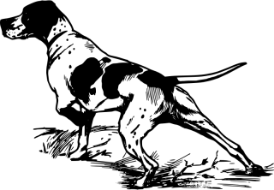

Field Trials & Training Days - July & September 2020
As many of you will be aware our events for the remainder of 2020 have been cancelled. On receiving the Kennel Club recommendations regarding future events in the Covid-19 pandemic (to the end of September) and in liaison with my Field Trial Sub Committee we made the decision to cancel our trials and training day at Apedale Moor on 27th, 28th & 29th July 2020 and at Sandringham on 10 & 11th September 2020. With so many uncertainties at the time and the KC advice we felt compelled to make this decision and in doing so minimise any risk for all involved. We are forever grateful to our hosts and keepers for allowing us on to their land for our events and we very much look forward to returning in 2021.

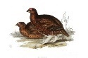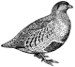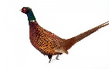

Diamond Jubilee International Field Trial Event Balmoral 2020
While our special event is not able to go ahead this year due to the Covid 19, I am delighted to confirm that we are able to postpone until 2021 with many thanks to Her Majesty the Queen.
The new date for this event is 16th August 2021

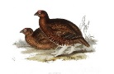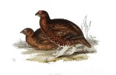

Sandringham 25 year booklet
I still have a small supply of these lovely booklets available if you would like to browse and read while we are getting back to the ‘new’ normal! They are £15 each including postage. Please email me if you wish to purchase a copy – crahanpointers@yahoo.co.uk

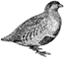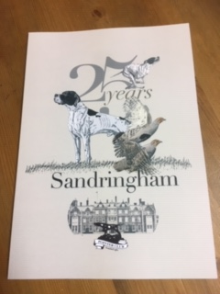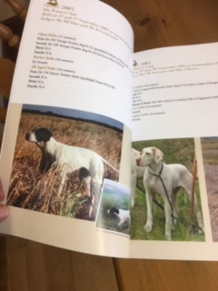

Carole Brown Field Trial Secretary

CANCELLED EVENTS 2020
Saturday 15 February Committee Meeting Red Lion Todwick
Saturday 29 February Contest of Champions at Thrumpton Hall
Sunday 15 March Show Gundog Working Certificate
Saturday 28 March Joint Pointer Club and English Setter Club Field Trial Training Day
Monday 30 March All Aged Stake
Sunday 5 April AGM at the Red Lion Todwick
Saturday 18 April Breed Championship Show at Newark
Saturday 23 May Breed Appreciation Day at Red Lion Todwick
Saturday 6 June Breed Open Show at Hasland
Sunday 24 May Zoom Committee Meeting
Monday & Tuesday 27 & 28 July Field Trials Reeth
Wednesday 29 July Joint Pointer Club and English Setter Club Field Trial Training Day
Monday 17 August International Field Trial: Balmoral
Thursday 10 & Friday 11 September Field Trials North Norfolk
Sunday 20 September Zoom Committee Meeting
Saturday 17 October Breed Open Show at Markfield Show Centre
Saturday 31 October Breed Appreciation Day Red Lion Todwick
Cancelled events

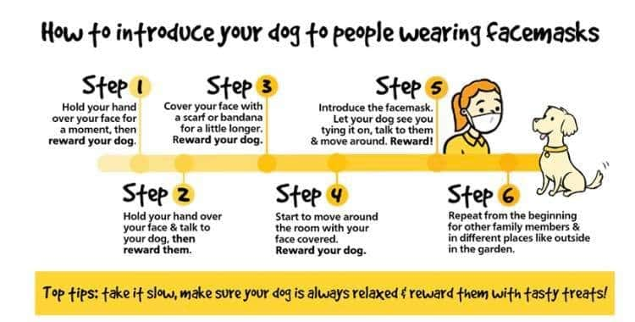
Contest of Champions 29/02/2020
This was our first big event for our diamond anniversary year. During the past five years there have been 40 new show champions, 19 dogs and 21 bitches, many of whom competed in this event, and a new male breed record holder, also competing. Most significantly we also honoured the achievements of our field trial competitors, who between them have made up 15 new field trial champions in the past five years.

CHAMPIONS, titles gained 2015 – 2019)
(competing at event)

VETERAN DOGS:
Sh Ch Coralwood Kanix Mr T
Sh Ch Gartarry Moonshine Over Staxyll
Ch Hurwyn Some Might Say JW
Int Sh Ch Kanix Fredrik
Sh Ch / Ir Sh Ch Moolou Minstrel at Hookwood JW ShCM
Sh Ch Sunhouse Anything Goes JW ShCM
Sh Ch Wilchrimane Igoyougo at Riowood

VETERAN BITCHES:
Sh Ch Freebreeze As You Like It ShCM
Sh Ch Fydal Ava
Sh Ch Ridanflight Rhianna
Sh Ch Ridanflight Rhonwen

DOGS:
Sh Ch Chesterhope Thrill Of T Chase
Sh Ch Fleurfield Jack Daniels
Sh Ch Freebreeze Over The Top at Spinray
Sh Ch Hookwood By George JW ShCM
Sh Ch Kanix Kingdom Over Cromasaig
Sh Ch / Ir Sh Ch Kanix Kroner of Sevenhills
Sh Ch Kanix News Flash at Glenfinnan
Sh Ch Millpoint Babe Magnet at Medogold JW
Sh Ch Sharnphilly Boondoggle
Sh Ch Sniperay Verandi
Sh Ch Tenshilling Home Alone JW ShCM
Sh Ch Wilchrimane C’Mon Norbet

BITCHES:
Ch Ansona Cinderella JW
Sh Ch Caithpoint Here And Now
Sh Ch Desfrisa Flirtini JW ShCM
Sh Ch Federika Fanfare at Woodglade
Sh Ch Joneva Asterea JW
Sh Ch Joneva Mrs Bridges JW
Sh Ch Kanix Kestrel
Sh Ch Kanix Orient at Stargang
Sh Ch Kanix Petunia at Stargang
Sh Ch Medogold Coralie of Pendan JW
Sh Ch Medogold Kiss and Tell JW ShCM
Sh Ch Millpoint Hopes N Dreams JW ShCM
Sh Ch Ridanflight Ruby Tuesday at Forthbourne
Sh Ch Sharnphilly Serendipity
Sh Ch Sunhouse Cheerio
Sh Ch White Squall Seasyde IceTea (Imp SA)
Sh Ch Wilchrimane Frankel

Our three judges were Jill Anthony, Jock Mackay and Geraldine O’Driscoll, who each drew lots to select their category. The event was run as a supermatch with dogs judged in pairs. The winners of each category were:

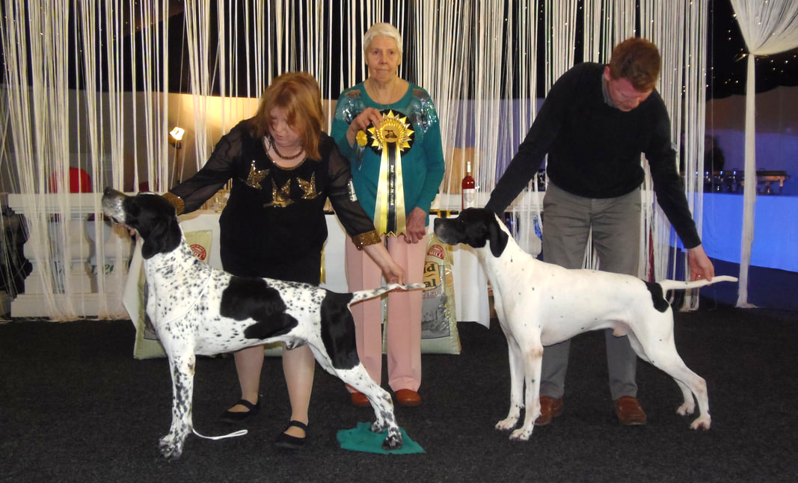
Judge Jill Anthony with veteran winner Int Sh Ch Kanix Fredrik (left)
and runner up Sh Ch Wilchrimane Igoyougo at Riowood (right)
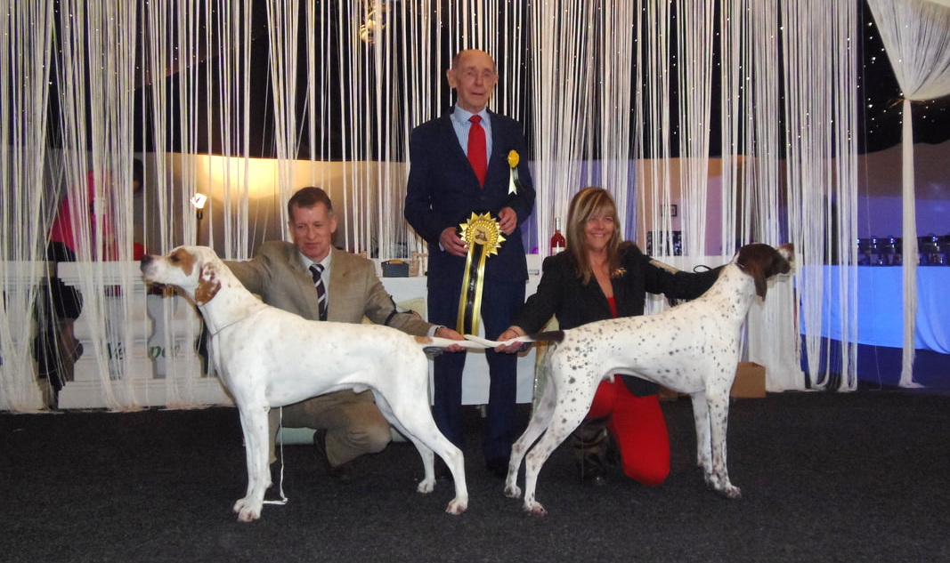
Judge Jock Mackay with dog winner Sh Ch Chesterhope Thrill of T Chase (left)
and runner up Sh Ch Freebreeze Over The Top at Spinray (right)

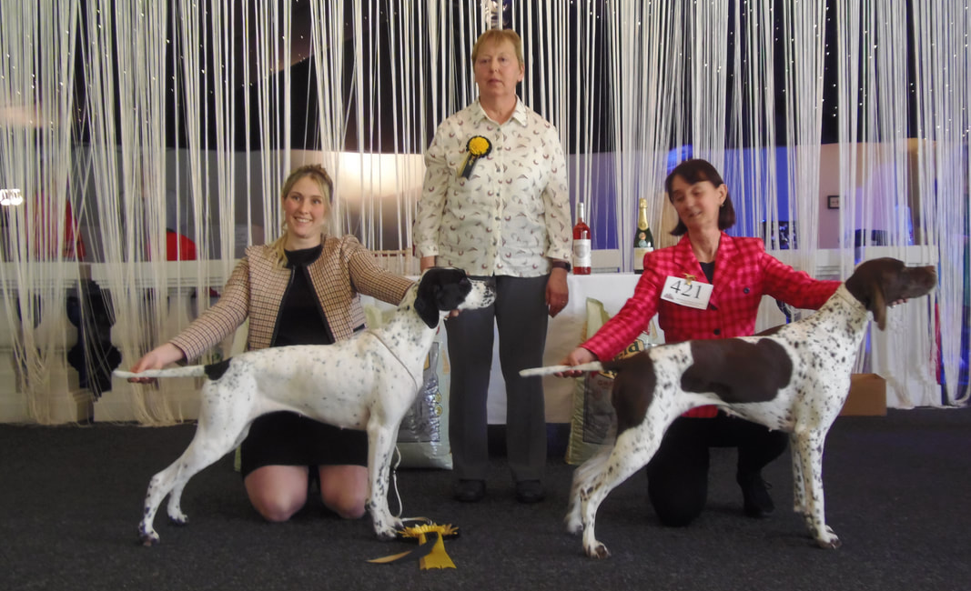
Judge Geraldine O’Driscoll with bitch winner Sh Ch Sharnphilly Serendipity JW (left)
and runner up Sh Ch Medogold Coralie at Pendan JW ShCM (right)

The match was ably compered by our show manager Tom Gorrian, and the overall winner was
Sh Ch Chesterhope Thrill of T Chase, our new joint breed record holder.
Our President Meryl Astbury gave a moving speech emphasisng the working abilities of the pointer, and introduced each of our Field Trial Champions.

FIELD TRIAL PARADE OF CHAMPIONS:
Brown: Ft Ch Ardclinis Emerald of Crahan
Hild: Ft Ch Ardclinis Eva of Gerensary
Houston: Int Ft Ch Ardclinis Francie Frank
Wilson Young: Ft Ch Fearn Quark of Burncastle
Lound: Ft Ch Frosted Elfin at Fleetstalk
Naylor: Ft Ch Gerensary Starlight of Bitternboom
Naylor: Ft Ch Goddrib Bari of Bitternboom
Westron: Ft Ch Goddrib Florence
Harris & Jacques: Ft Ch Koram Gemma Sparkfield
Jacques: Ft Ch Koram Kasbah at Sparkfield
Jacques: Ft Ch Koram Mick
Hild: Ft Ch Merlino of Morness
Hild: Ft Ch Morness Abba
Langford: Ft Ch Papermill Flashman
Dalton: Ft Ch Shannaghview Gershwin De Lagopus

It was then time for the lovely hot buffet, followed by the announcement of special prizes and raffle.
Finally came the cutting of the anniversary cake by our Secretary Trish Eldridge and Field Trial Secretary Carole Brown
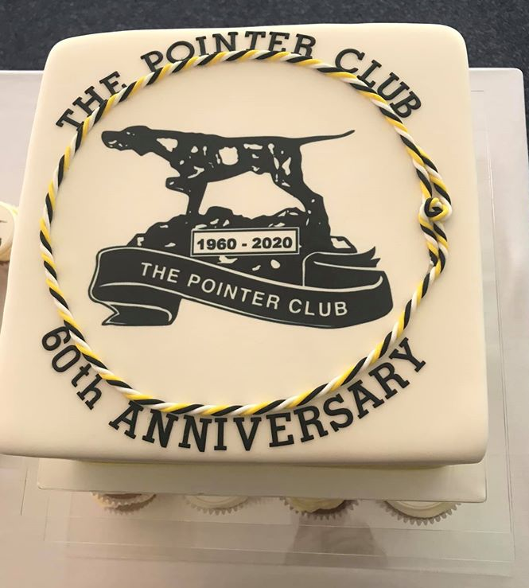
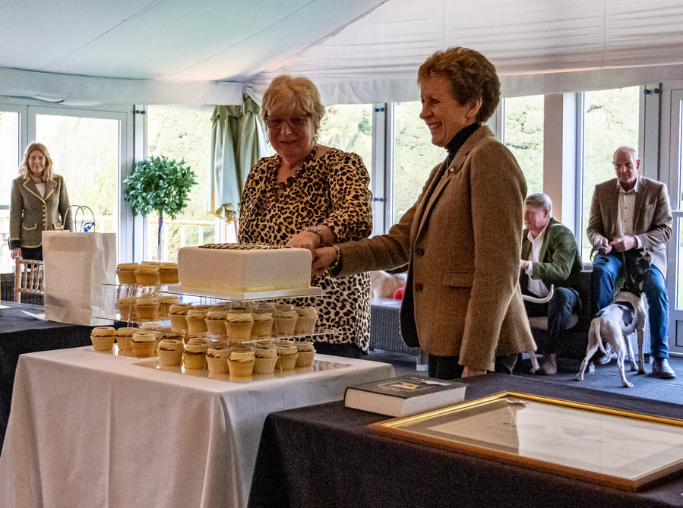

Such a joy for all pointer enthusiasts present to have this opportunity to meet and socialise: none of us had any idea that this was to be our first and last event of our anniversary year. How fortunate we were to witness the best of the best from the past five years. Patricia Eldridge (Acting Honorary Secretary)
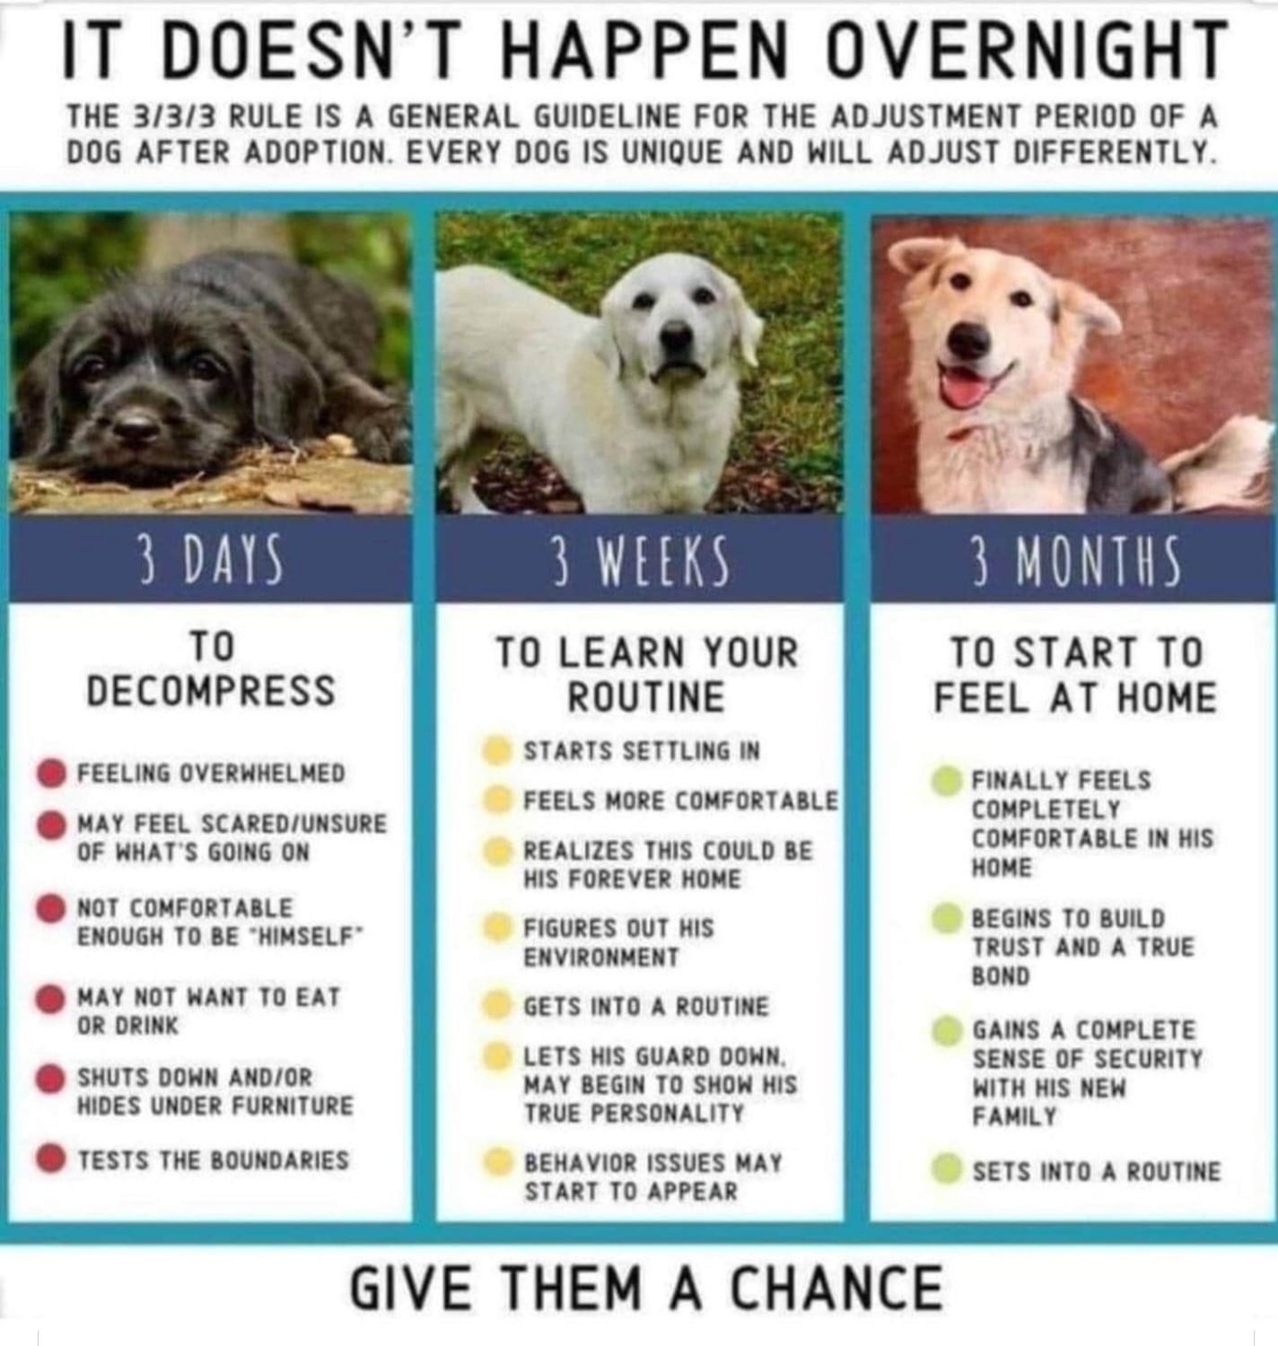

Planned Litters
Mrs Patricia Eldridge 01530 450177 patricia.eldridge@ntlworld.com September
Bradgate 07846 560926 bradgatepointers@gmail.com

Mrs Jackie Radcliffe 01768 894937 jackiesniperay@icloud.com September
Sniperay
Puppy List
Championship Show Results 2020
Date | SHOW | JUDGE
10 Jan  Best Dog  Res Best Dog  Best Bitch  Res Best Bitch  Best Puppy | Boston  *Sh Ch Sharnphilly Boondoggle JW  Meadowpoint Spirit of Fire  Hawkfield Bronze for Alozia ShCM  Sh Ch Sharnphilly Serendipity JW  Wilchrimane Tambuti with Kiswahili | Ms J Nicholls
19 Jan  Dog CC  RDCC  Bitch CC  RBCC  Best Puppy | Manchester  Sh Ch Sharnphilly Boondoggle  Kanix Obi at Stargang  *Sh Ch Kanix Petunia at Stargang  Sh Ch Sharnphilly Serendipity  Chesterhope C’Mon Over to Carmandine (Imp) | Mrs Y Kent  PG 2
6 March  Dog CC  RDCC  Bitch CC  RBCC  Best Puppy  Best Veteran | Crufts  Ch Ratchda’s Rock Thrush  Sh Ch Chesterhorpe Thrill Of T Chase (IMP NZ)  *Ch Ansona Cinderella JW  Sh Ch Federica Fanfare at Woodglade  Hawkfield Jolly  Sh Ch Sharnphilly Juici Cuture JW | Mrs L Pimblett  (3rd CC)

Championship League Tables 2020 (2 sets of CCs)

Top Dog and Top Bitch Competition
The points system works as follows: your dog gains four points for a first CC, 1 point for each subsequent CC plus one for best of breed where CCs are on offer. A group win at a championship show scores five points (as does best in show at a single group, or Scottish Breeds championship show); group 2 three, group 3 two and group 4 one point. Best in show at an all-breeds championship show scores an extra ten points, reserve five. One extra point goes to BIS at a working/pastoral breeds championship show. Rare breeds score two for best of sex plus one for BOB at championship shows where they have breed classes; imported register breeds score similarly in championship show classes open to all IR breeds in that group.

Top Dog Competition | CC+  BOB* | POINTS | GROUP POINTS | TOTAL
Sh Ch Sharnphilly Boondoggle | 1 | 4 |  | 4
Ch Ratchda’s Rock Thrush | 1 | 4 |  | 4
Top Bitch Competition | CC+  BOB* | POINTS | GROUP POINTS | TOTAL
Sh Ch Kanix Petunia at Stargang | 1* | 4+1 |  | 5
Ch Ansona Cinderella JW | 1* | 4+1 |  | 5

Top Puppy Competition Points to be awarded as follows:
Breeds with CCs: Best Puppy In Breed at shows where CCs are on offer for that breed – 1 point.
CC won by a puppy winning BPIB– 1 extra point. New Puppy Group points 1st 5 points 2nd 3 points 3rd 2 points 4th 1 point. All Best Puppy In Breed awards at Specialist Club Championship Shows will be awarded an extra point, to be used only in the event of a tie break.

Top Puppy Competition | WINS | POINTS | GROUP POINTS | TOTAL
Chesterhope C’Mon Over to Carmandine (Imp) | 1 | 1 | 3 | 4
Hawkfield Jolly | 1 | 1

Top Stud Dogs and Brood Bitches 2020 (2 sets of CCs)
Top Stud Dog Competition New Rules
When a dog or bitch wins its first CC of the year, it scores four points for its sire. If it wins a second, third, fourth, fifth or sixth CC during the year, it scores an extra point, so that the maximum one dog can score for its sire is nine points, plus one point for BOB on any of the first six occasions
Top Brood Bitch Competition New Rules
When a dog or bitch wins its first CC of the year, it scores four points for its sire. If it wins a second, third, fourth, fifth or sixth CC during the year, it scores an extra point, so that the maximum one dog can score for its sire is nine points, plus one point for BOB on any of the first six occasions, new maximum 15 points

Stud Dogs | Points | Sire / Dam of CC Winner | Brood Bitches | Points
Sh Ch Chesterhope Thrill Of T Chase (IMP NZ) | 4 | Sh Ch Sharnphilly Boondoggle | Sh Ch Sharnphilly Juici Cuture JW | 4
Wilchrimane Up to Tricks | 4+1 | Sh Ch Kanix Petunia at Stargang | Sh Ch Kanix Chilli | 4+1
Ch Billsborough’s Bright Moon JW | 4 | Ch Ratchda’s Rock Thrush | Ratchda’s Rosefinch | 4
Sh Ch Hurwyn Law N Order JW | 4+1 | Ch Ansona Cinderella | Sh Ch Ansona Lucy Lockett | 4+1

Top Stud Dogs 2020
Wilchrimane Up To Tricks 4+1 5
Sh Ch Hurwyn Law N Order 4+1 5
Sh Ch Chesterhope Thrill Of T Chase (IMP NZ 4 4
Sh Ch Billsborough’ Bright Moon JW 4 4

Top Brood Bitches 2020
Sh Ch Kanix Chilli 4+1 5
Sh Ch Ansona Lucy Lockett 4+1 5
Sh Ch Sharnphilly Juici Cuture JW 4 4
Ratchda’s Rosefinch 4 4

Top Breeder Competition 2020
This competition identifies the most consistent breeder of top winning dogs within each breed.
Points to be awarded as follows: Breeds with CCs
First CC in calendar year won by each dog – 4 points
Subsequent CCs in calendar year – 1 point each BOB 1 point each*
New Rules: Group points not counted in breeder total

Breeder(s) Affix CC Points BOB Total + (Group)
Blackburn-Bennett & Wilberg Kanix 4 1 5
Grime Ansona 4 1 5
Dyer & Oddie Sharnphilly 4 - 4
Marsh Ratchda 4 - 4

FERNSLAW

100,000 petition signatures reached
Open until 4th September 2020
If your stolen dog was taken to the vets by a new family would you want the vets to scan & check their microchip ID? YES - THEN PLEASE SIGN AND SHARE to make it compulsory to check microchip ID at 1st treatment to reunite missing microchipped pets. We need 100,000 signatures to close this cruel loophole #FernsLaw petition.parliament.uk/petitions/300010

Check list for more signatures:-
Shared on Facebook groups and my timeline, tagged friends?
Tweeted?
Emailed friends and family?
Added to WhatsApp groups?
Added to Instagram?
WE DID IT WITH YOUR HELP
100,000 #FernsLaw petition signatures

We should hear from the Government’s Petition Committee next week, as we make plans for our debate in Parliament. In the meantime, it would be really useful if you could email your own MP, asking them to support our campaign and if they will contact the relevant Ministers.
We have prepared a template letter, which you can adapt if you have a missing microchipped pet, all the information is in this link:- https://vetsgetscanning.co.uk/email-your-mp-to-help-get-the-legislation-needed-for-fernslaw-and-protect-our-pets/

We will update you with our progress.
PS: The petition is open for signatures until the 4th September 2020, so please feel free to keep getting new signatures, the more the merrier!

THANK YOU THANK YOU THANK YOU

HOW MUCH FOR A PUPPY?

Let me say a few words to you, yes you, the person who writes an email to simply ask the price. The person who calls and after hearing a price surprisedly states: “I can buy a cheaper pup elsewhere”. I also address you; the person who doesn’t care about papers because I want “just a pet”.

Let me REMIND you
No dog is “just a pet”.

Behind every pure-bred puppy/dog is a BREEDER. I’m using capital letters to differentiate a breeder from a pet factory or mill. A reputable breeder does not breed dogs without papers, that does not protect the integrity of the breed. Registration (papers) are records of lineage that document bloodline and allow one to research any possible health issues present in the lineage. When you tell a Breeder you don’t care about papers what you’re really telling them is you couldn’t care less about the health of the puppy you just want the cheapest thing you can find! When you select to buy a puppy from a reputable and quality breeder, this breeder is responsible for the health of every pup; both dogs owned and every pup they’ve sold for its lifetime. This breeder will skip holidays, miss sleeping, and most of their personal house space has been turned into space for their dogs. The truly passionate breeder who loves what they breed, puts their whole heart and soul into it. Not only in puppies that are sold, but also in each client who owns a piece of their heart and now is a member of their extended family. This does not take into account any puppy/dog who might get sick or need extra help to thrive. Breeders worry about their babies after they leave and will take one back without question.

A breeder will get their hands dirty, often covered in everything accompanied with birthing. Because that’s what life is about...In the middle of birth and death is life. The wheel that keeps turning. A breeder will do tests, echoes, x-rays, analysis, emergency c sections, vaccinations, register litters, research pedigrees, deworm, as well as microchip their puppies and get them evaluated by specialists.

Last but by no means least, a breeder CHOOSES the family lucky enough to have one of their puppies. Yes, you read that right. A true breeder chooses who they sell to because they are not making money off the sale. There is no compensation that can offset the investment a Breeder has made so they need to be confident it’s the right fit. Many times saying more no’s then yes...A good Breeder will have different criteria for those wanting to carry on their bloodline, why? Because breeding is not a responsibility to ever be taken lightly, it’s a lifestyle choice set aside for ONLY the few devoted people willing to sacrifice.

Because a dog is never “just a pet” it’s the Breeder’s legacy, a little boy’s best friend, a little girl’s protector, an elderly person’s therapy, a member of the family, someone’s whole world!!!

Written in part by: Sr. Eduardo Loredo Muller
Translated into English by: Angel Sophia Nogga
Modified for dogs by: Amber French

Rainbow Bridge
Sky: Tafakis For My Love 07/07/2006 - 26/12/2019
Flicka: Freebreeze Reflected Glory 09/11/2007 – 08/02/2020
Merlin: Medogold Night Knight 09/01/2009 - 16/02/2020
Lettie: Bonnygate Jet Lady 27/02/2004 - 24/02/2020
Carly: Kanix Calypso by Kiswahili 29/06/2010 - 03/03/2020
Monty: Pharises Perseus JW 09/02/2008 - 04/03/2020
Wilma: Hilldon Newzflash 24/06/2008 - 13/03/2020
Jago: Moenfair Spicewood Summer ShCM 11/06/2014 - 20/03/2020
Scout: Ch Hurwyn Some Might Say JW 01/11/2007 - 24/03/2020
Jake: Whipspan Paul Hogan to Jakobstown 13/11/2007 - 26/03/2020
Narsil: Ch Dunharrow of Szedresi 29/09/2005 - 29/03/2020
Bart: Bradgate Magic Maestro 28/09/2006 - 29/03/2020
Tolly: Jilony Live A Little with Kiswahili 23/07/2005 - 11/04/2020
Dominoe: Teisgol Cassiopia 06/07/2004 - 20/05/2020
Beamer: Carofel Just A Minute 22/05/2007 - 10/06/2020
Splash: Medogold Wannabeposh for Lappakia 06/08/2006 - 14/06/2020
Zakk: Papermill Border Raider 29/09/2008 - 04/08/2020
Floosie: Tomlow Look Who’s Here at Hawkfield 04/06/2009 - 07/08/2020
Ringo: Rodale Ringleader 24/08/2007 - 17/08/2020
Phoebe: Haramander Diamond Lil: 03/03/2008 - 17/08/2020
Nemo: Multi Sh Ch Ledgands Magic N Mayhem 28/10/2006 – 20/08/2020

Losing a dog leaves a hole in your heart,
You simply just wait for your life to restart.
The hurt is so deep that you wonder just how,
You’ll ever recover from pain you feel now.
But time is a blessing and memories are gold.
The years that you loved her and watched her grow old,
Are gifts that she leaves you to treasure and then,
One day you’ll see her and love her again.

Newsletter Editor: Trish Eldridge
1, Holly Hayes Road, Whitwick
Coalville, Leics LE67 5GG
Tel: 01530 450177
e-mail: patricia.eldridge@ntlworld.com
bradgatepointers@gmail.com

