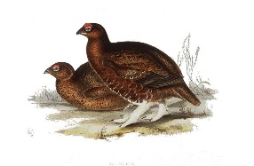
THE POINTER CLUB
DIAMOND JUBILEE EVENT
INTERNATIONAL TEAM EVENT FOR POINTERS ON GROUSE
AT THE BALMORAL ESTATE, SCOTLAND
BY KIND PERMISSION OF HER MAJESTY THE QUEEN
MONDAY 16TH AUGUST 2021
This promises to be a very special event with teams representing England, Scotland and Ireland each consisting of four pointers and handlers. The event will run as a traditional day shooting grouse over pointers.
Our headquarters for the event is Douneside House, Tarland with a special awards dinner to be held on the evening of 16th August.
SPECTATORS
ACCOMMODATION – I am pleased to confirm there are a few spare rooms available at our headquarters. If you would like to book a room please contact me by 10th June with your request. Please note rooms may not be available after this date.
INTERNATIONAL TEAM EVENT – Spectators are very welcome to attend providing security forms have been completed and returned to me ahead of the event. Meeting place to be confirmed. Please contact me if you wish to attend the daytime event.
AWARDS DINNER – The awards dinner will be held at Douneside House at 7.30pm on Monday 16th August. Tickets are available at £35 per person. Numbers will be limited and will be available on a first some first served basis
Look forward to hearing from you
Carole Brown Honorary Field Trial Secretary
crahanpointers@yahoo.co.uk

